[Attached Table 2]

Standards for Mark of Advertisement Review Completion on Medical Device (in connection with Article 6 paragraph 2)
1. Design of the mark of advertisement review completion
A. Design
Advertisement Review Completion
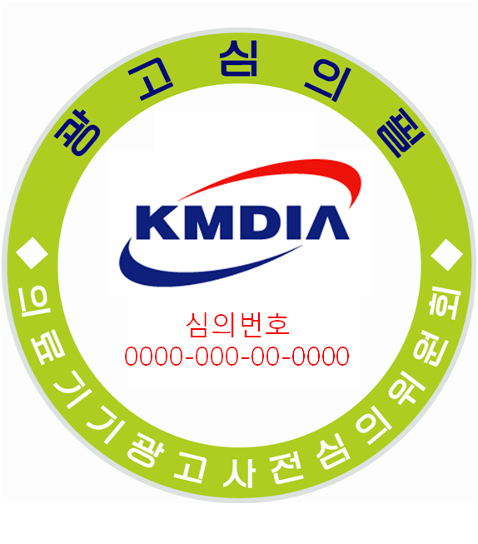
Review Number
Committee of Prior Review of Advertisement on Medical Device

B. Diameter: 3.5cm or greater
C. Text Size of ‘Review Number’: The print size of the font shall be the minimum 6 in the Korea Standard KS A 0201 (standard size of prints) in order to make it distinctive from others.

